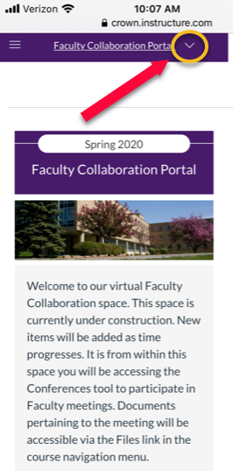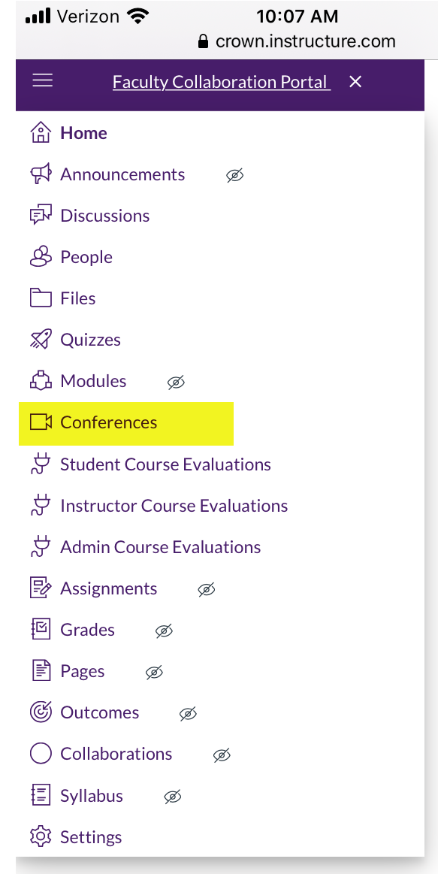

Open a browser on your mobile device and login to Canvas. Open the course and select the pull down menu as indicated in the first screenshot. From the menu select conferences and then Join the link to the faculty meeting which will take you to Big Blue Button as seen in screenshot 3.

